
Bureau of Health Promotion, Department of Health, Executive Yuan, Taiwan R.O.C

The Safety Issues of Handling Hydrofluoric Acid

Instruction Organization: Bureau of Health Promotion, Department of Health, Executive Yuan, Taiwan R.O.C
Executive Organization: Taichung Veterans General Hospital
What is hydrofluoric acid?
- Hydrogen fluoride molecules combine to each other by covalent bonds.
- Hydrogen fluoride is water soluble; once dissolved in water, it forms hydrofluoric acid.
- The concentration of hydrofluoric acid available commercially is 35~50% solution; the highest concentration can be up to 75%.
- It should be diluted before use, but as low as 1% of hydrofluoric acid can still cause intoxication.
- Hydrofluoric acid is a kind of weak acids.

Trivial Names of Hydrofluoric Acid
Fluoric acid
Bone acid
Bone dissolving acid
Diamond cleaning solution
Rust cleaning solution
Pickle
In what areas, would hydrofluoric acid be used?

- Refrigeration  - Corrosion  - Glass polish  - Chemical fertilizer, pesticide  - Dyes, plastic, solvent  - Condenser  - Production of high-octane petroleum  - Semiconductor industry  - Household rust cleaner  - Ceramic tile polisher and cleaner | 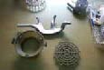  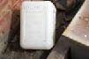  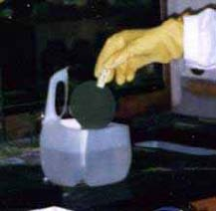

What are the ways to expose to hydrofluoric acid?

- Inhalation  - Skin and mucous membrane  - Uptake | 
It is harmful to eye mucous membrane and skin.
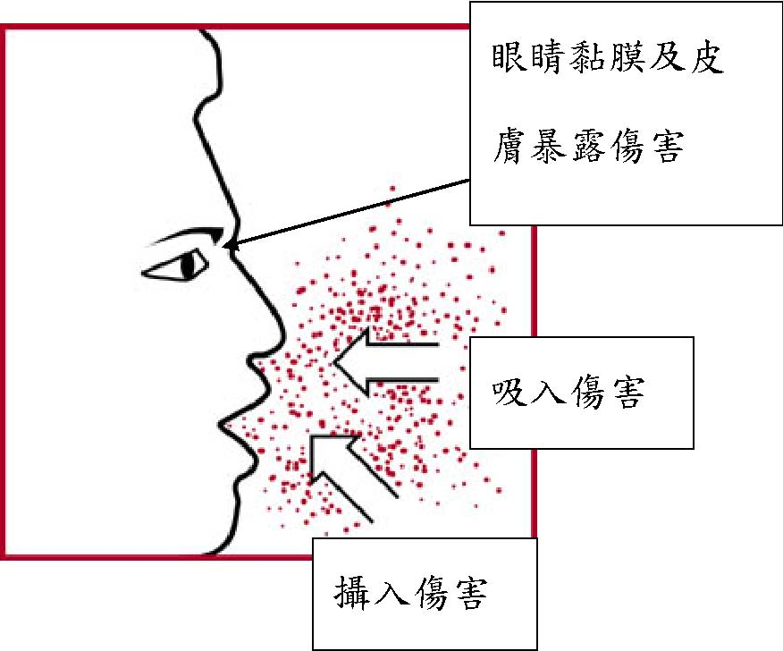
It is harmful by inhalation.
It is harmful by uptake.

How does hydrofluoric acid cause an injury?
- Hydrofluoric acid corrodes tissues to form tissue coagulation. Due to its weak acidity, burned skin crust cannot form or forms in a very slow way, but the underneath skin tissue has been damaged giving that hydrofluoric acid is more penetrative than other strong acids.
- Fluorine ions can even penetrate into bones and blood circulation system.
- As fluorine ions have a high affinity to calcium and magnesium, hydrofluoric acid intoxication may lead to hypocalcemia, hypomagnesemia and hyperkalemia. These conditions are followed with symptoms of intoxication such as lethal arrhythmia.
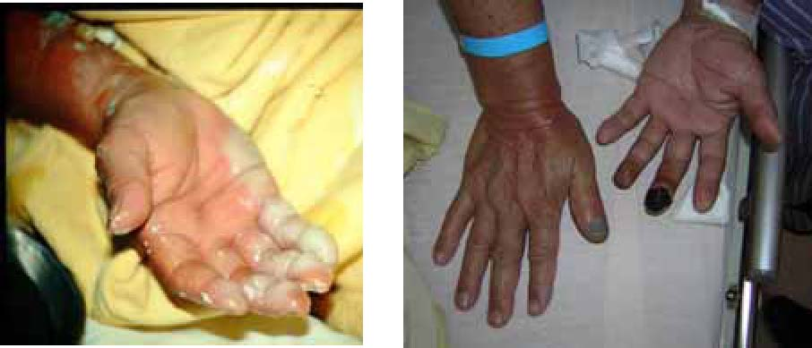
What are the symptoms of hydrofluoric acid intoxication?
- Respiratory System: bronchial spasm, laryngeal spasm, airway edematous change. These symptoms would appear 12~24 hours after intoxication occurs.
- Cardiovascular System: hypoxemia and lethal arrhythmia caused by electrolytes imbalance such as hypocalcemia, hypomagnesemia and hyperkalemia.
- Nervous System: hypocalcemia, hypomagnesemia, muscle twitching and fasciculation.

What are the symptoms of hydrofluoric acid intoxication?
- Skin and mucous membrane: the degree of injury depends on the length of time exposed to hydrofluoric acid and its concentration.
  - When the concentration of hydrofluoric acid is lower than 10%, pain usually happens 6~24 hours after exposure.
  - When the concentration of hydrofluoric acid is between 10~50%, pain usually occurs between 30 minutes to 6 hours after exposure.
  - When the concentration of hydrofluoric acid is higher than 50%, pain appears immediately.

What are the symptoms of hydrofluoric acid intoxication?
- Chemical burns caused by hydrofluoric acid usually give patients an extreme pain that usually is not comparable to the results of medical examinations; it is like the pain without having an external trauma.
- If eyes were exposed to hydrofluoric acid, the outcome could be very serious leading to a permanent loss of sight, ablepsia.

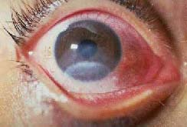

What protection can be done against hydrofluoric acid?
- Eye protection: People when handling hydrofluoric acid should wear safety glasses or a complete cover mask.
- Body protection: People when handling this chemical should wear a jump suit made of rubber and a pair of working boots.
- Breathing protection: People who handling this chemical should wear a filtering gas mask.
- Hand protection: People when handling this chemical should wear a pair of impervious gloves made of polyvinylidene fluoride (PVDF) or natural rubber; cloth gloves as giving no protection should not be worn.
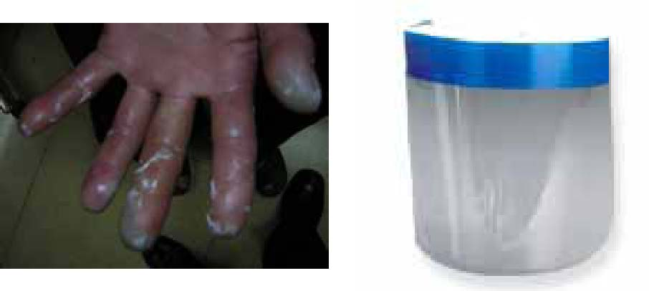

What are the emergency measures to handle accidental exposure to hydrofluoric acid?
- The person exposed to hydrofluoric acid should take off all cloths and take a shower with plenty of water for at least 30 minutes.
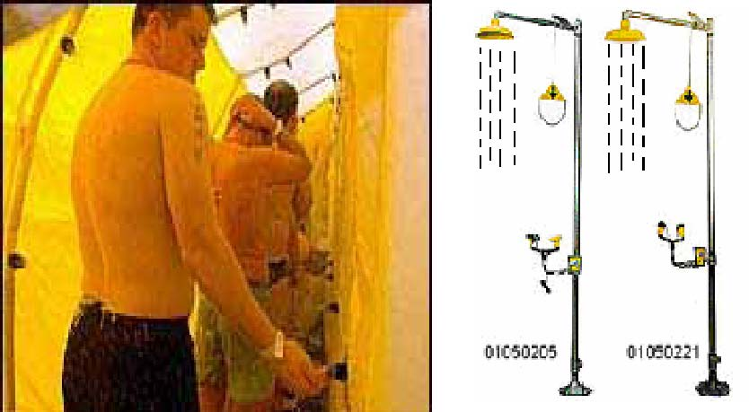
- Skin exposure and treatment: After taking the shower, apply the ointment containing calcium gluconate or calcium oxide and magnesium oxide; keep applying for at least 30 minutes until the pain is relieved for more than 15 minutes.
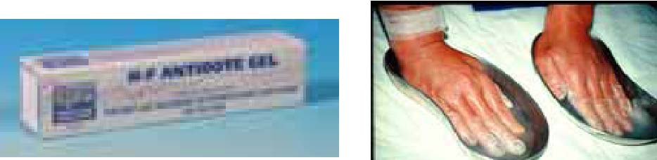
- Oral uptake of hydrofluoric acid: vomit cannot be induced; theoretically the person who mistakenly takes this chemical can be given milk, calcium containing solution, calcium tablets, magnesium containing stomachache palliatives.
- Handling eyes in contact with hydrofluoric acid: the eyes should be washed with water for 30 minutes or washed with more than one liter of water or normal saline.
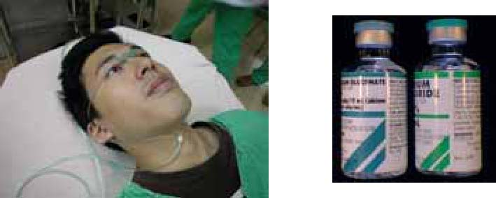
- Handling inhalation of hydrofluoric acid: remove the chemical and give the person who inhales this chemical 100% oxygen.
- Contact antidote control center:
Tel: 02-28717121
04-23592525#3610
04-23599783
- Immediately go for medical treatments: inform physicians that the person is exposed to hydrofluoric acid.



Drawn up and edited by Division of Toxicology, Emergency Department, Taichung Veterans General Hospital
Printed with subsidy from Bureau of Health Promotion, Department of Health, Executive Yuan, Taiwan R.O.C

